IMS Administration Foundation for z/OS
Hands-on-Lab Guide

Table of Contents
How to access the hands-on environment 2
Scenario 1: Monitor IMS databases 4
Steps 4
Scenario 2: Review IMS system components and resources 8
Scenario 3: Search IMS objects 14
Scenario 4: Use the IMS Catalog to query DBD/PSB information 17
Scenario 5: Run IMS SQL for application databases 20
Scenario 6: Run IMS type-1 and type-2 commands 23

How to access the hands-on environment
- Receive your user ID and password from the hands-on instructor.
- Open a web browser and access the following URL (Zowe Virtual Desktop):
https://zos.dev:7556/ZLUX/plugins/org.zowe.zlux.bootstrap/web/
- When the login screen appears, enter the user name and password you received in step Note: Passwords are case-sensitive.
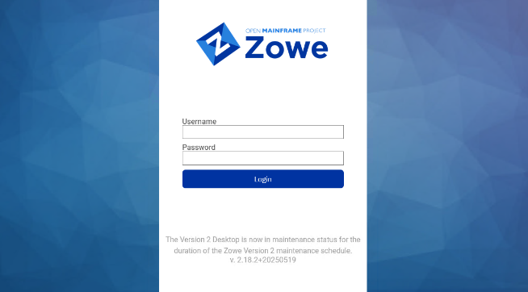
- After a successful login, click the Z icon in the lower-left corner to open the menu.
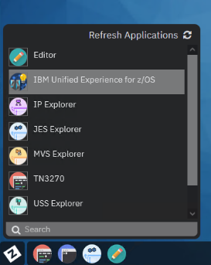
- From the menu, click “IBM Unified Experience for z/OS”.

If you see a screen like the one on the next page, setup is complete. You are ready.
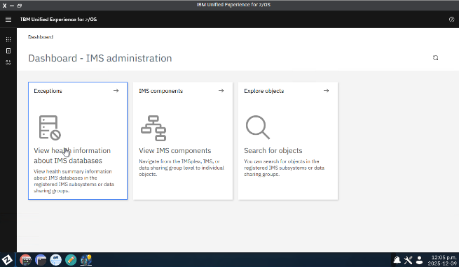

Now, you can start from any hands-on scenario in the following list:
- Scenario 1: Monitor IMS databases
- Scenario 2: Review IMS system components and
- Scenario 3: Search IMS objects
- Scenario 4: Use the IMS Catalog to query DBD/PSB information
- Scenario 5: Run IMS SQL for application databases
- Scenario 6: Run IMS type-1 and type-2 commands

Scenario 1: Monitor IMS databases
In this scenario, you use the following functions (Enhanced IMS management features) to check IMS database status.
Assumed situation: You are an IMS database administrator. To see if there is any issue or potential issue in a monitored database, you use IMS Administration Foundation dashboard to:
- Display a list of database exceptions (alerts)
- Display database statistics and their trends over time

Steps
- On the dashboard, click the left-most tile: “Exceptions”.
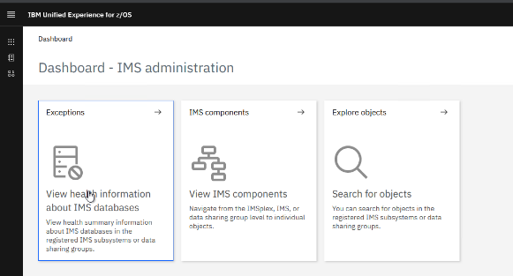
If this dashboard is not visible, click “IBM Unified Experience for z/OS” in the upper-left to return to the dashboard.
- The next screen shows a list of databases with detected exceptions (alerts).
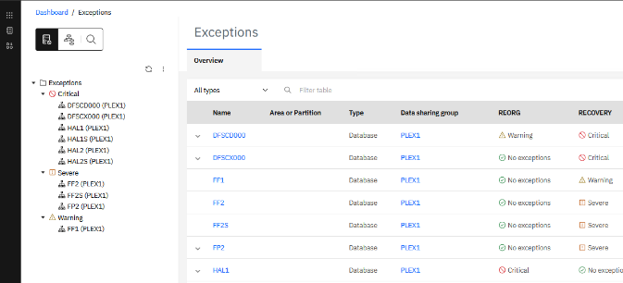
Check whether there is any critical issue across all monitored IMS data sharing groups.

- Next, investigate one specific database in more detail.
To select the database HAL1 in the data sharing group PLEX1, click “HAL1 (PLEX1)”. Then, a list of exceptions (alerts) for that database is shown on the right pane.
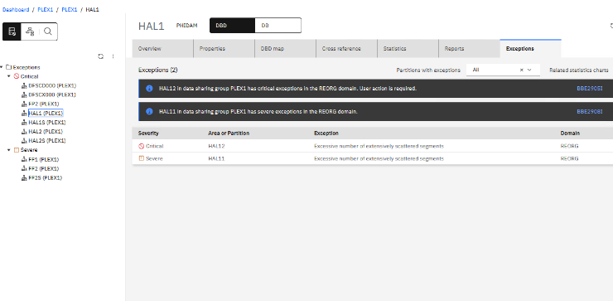 Tip: Clicking the message number on each message displayed, a relevant User’s Guide page will be open in a new browser tab.

- Click a row that has a critical severity is reported with a red icon.
Then, a description of the reported exception and a small trend chart of the related statistics is displayed.
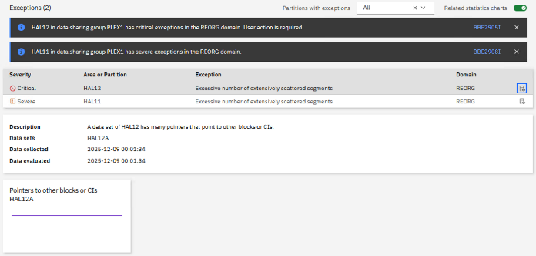


- Click the small trend chart at the bottom to open a more detailed view.
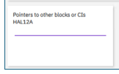
You can review detailed time-series changes and related statistics if any.
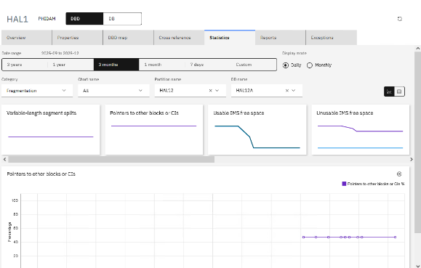

- To focus on recent statistics, adjust the date range in the “Data range” area.
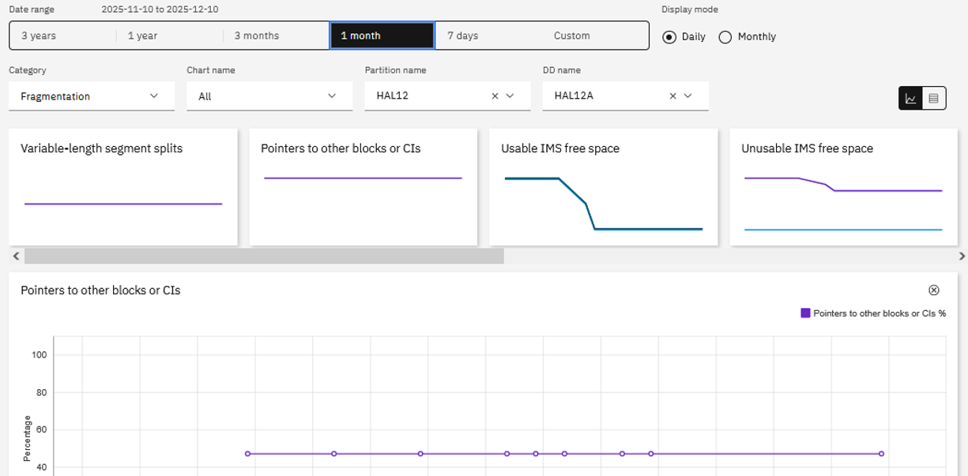

- The default view is a chart. Use the button in the upper-right to switch between chart and table.
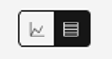
In table view, you can export to CSV for analysis or sharing with your team.
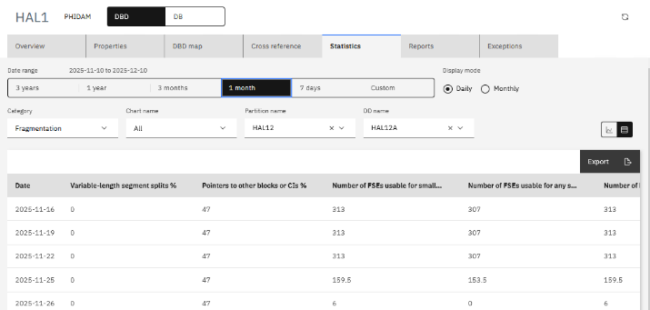

This completes Scenario 1.

Scenario 2: Review IMS system components and resources
In this scenario, you use the following functions (Base features) to review IMS component configuration and status:
- Display a list of resources defined in IMS
- Drill down to view resource attributes and dependencies


- On the dashboard, click the center tile: “IMS components”.
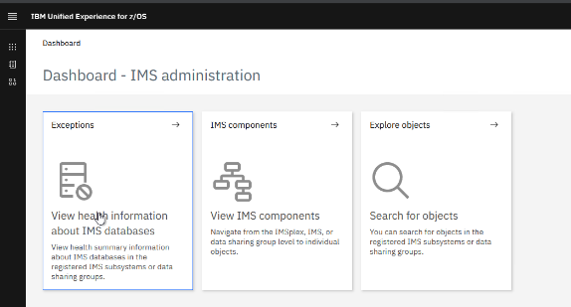
If this dashboard is not visible, click “IBM Unified Experience for z/OS” in the upper-left to return to the dashboard.
- The next screen shows a list of managed IMS instances and other IMSplex components.
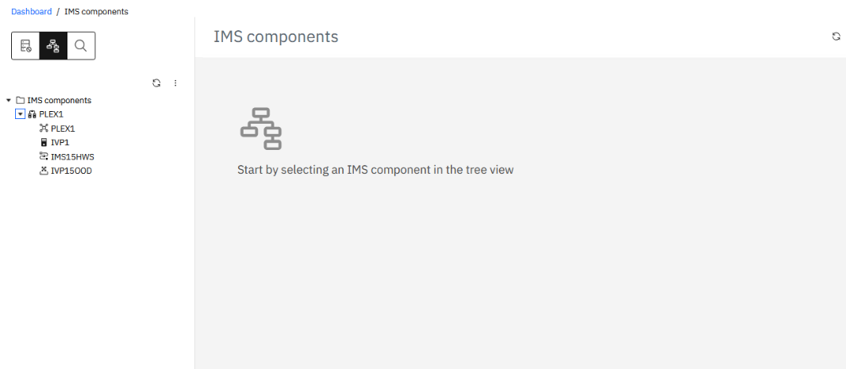

- From the top-level list, select “PLEX1”.
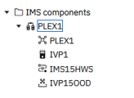
This is one IMSplex in the hands-on-lab environment. Clicking it displays an overview: the IMS components in that IMSplex and totals by resource type.
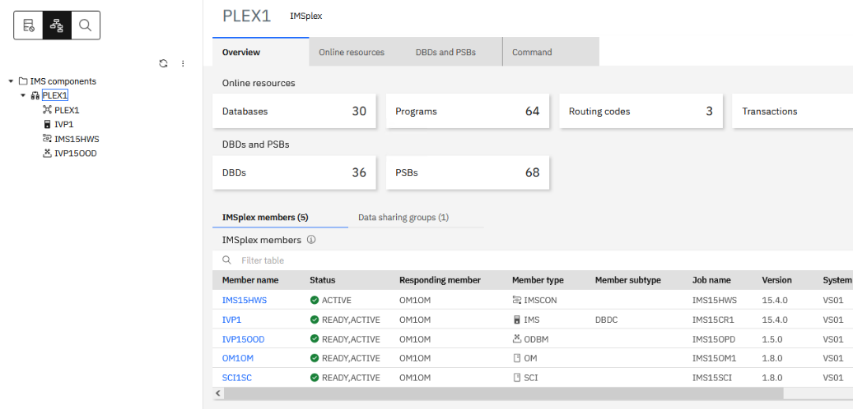

- Drill down into a specific resource type. In this example, drill down into DBDs. Click the “DBDs” tile.
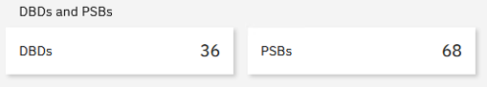
Confirm that a DBD list is displayed.
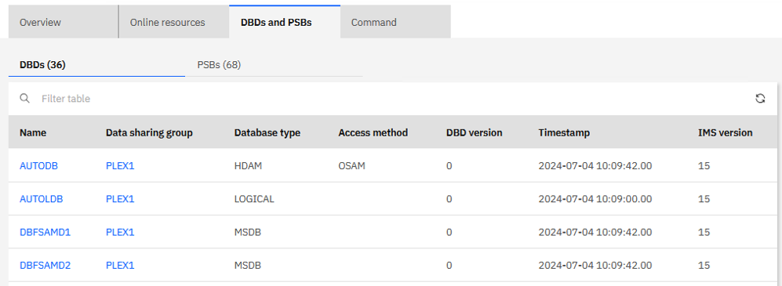
Tip: In this page, you can switch tabs to display the PSB list.
- Click a DBD name to view the details of its definition.
Here, select the first entry: “AUTODB” (blue text).
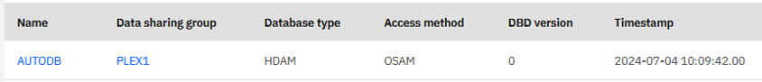
- The DBD details page shows the selected DBD “AUTODB” with attribute information and dependencies.
You can see items such as indexes, related physical/logical DBDs, and related PSBs.
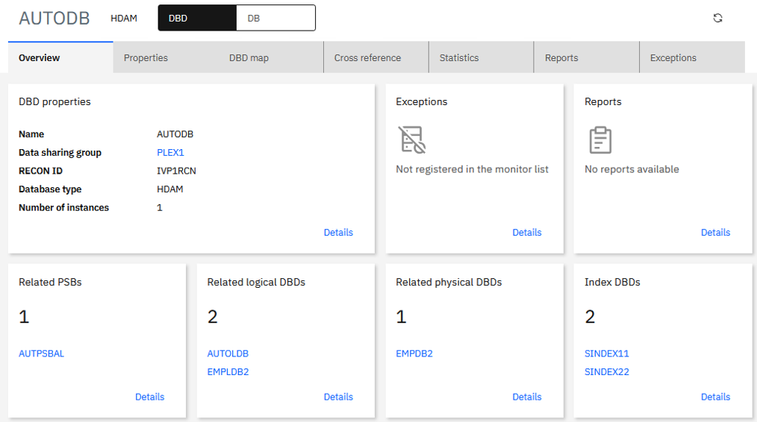
- Select the “DBD map” tab to display a graphical view of the segment structure.
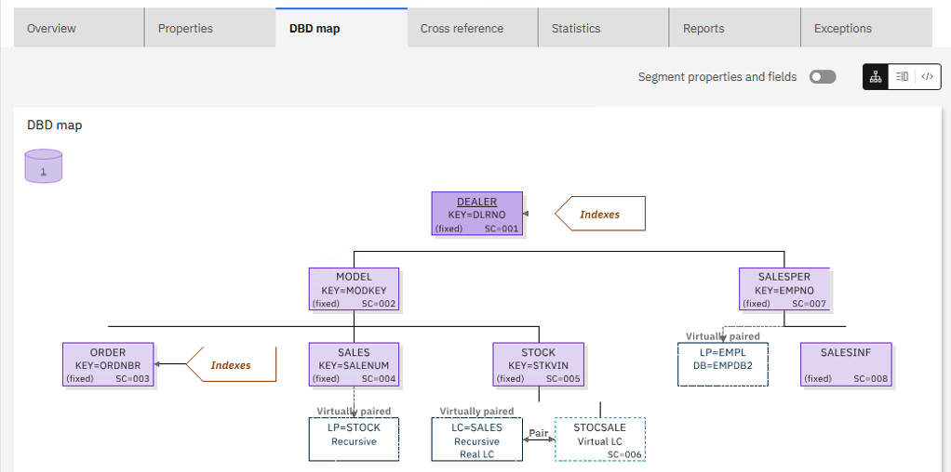
- In the graphical view, you can display segment tree and DBD source side-by-side.
Click the following icon.
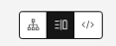
Clicking a specific section in source highlights the corresponding view (and vice versa).
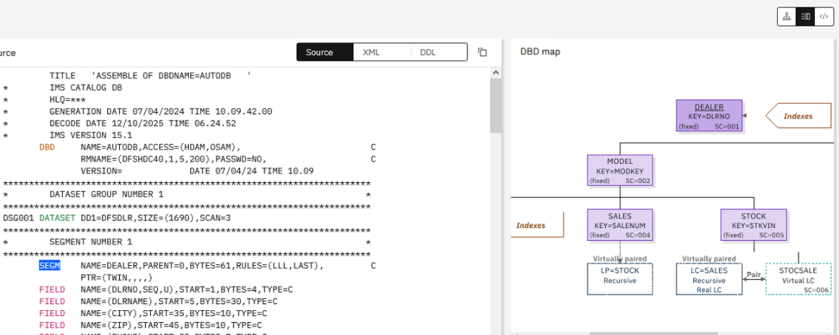
Click the “DDL” button to display IMS DDL.
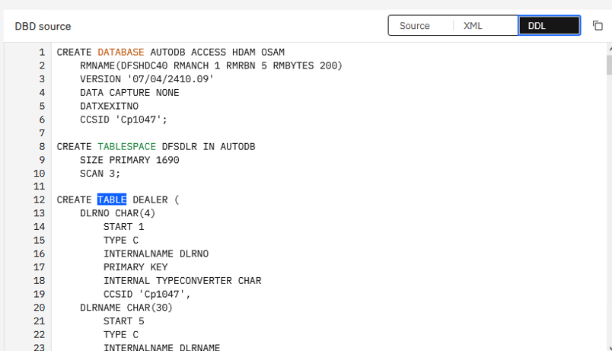

- Finally, review resources that have dependencies on this DBD.
First, check the online DB resource that corresponds to the selected DBD.
Click the “DB” button at the top to display attributes for the DB resource.
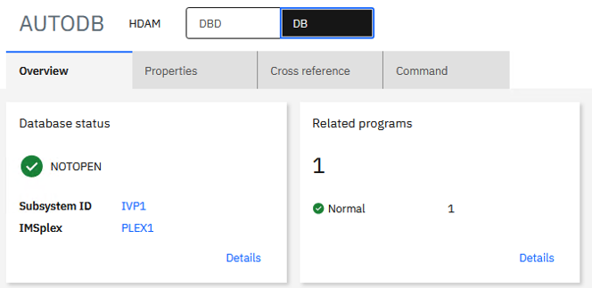

- Next, the PSB that references this DBD.
Return to the DBD view and click “Related PSBs” in the Overview tab.



- Click “AUTPSBAL” to view the PSB “AUTPSBAL” attributes and dependencies.
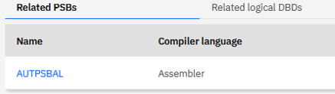
This makes it easy to review dependent resources as well.
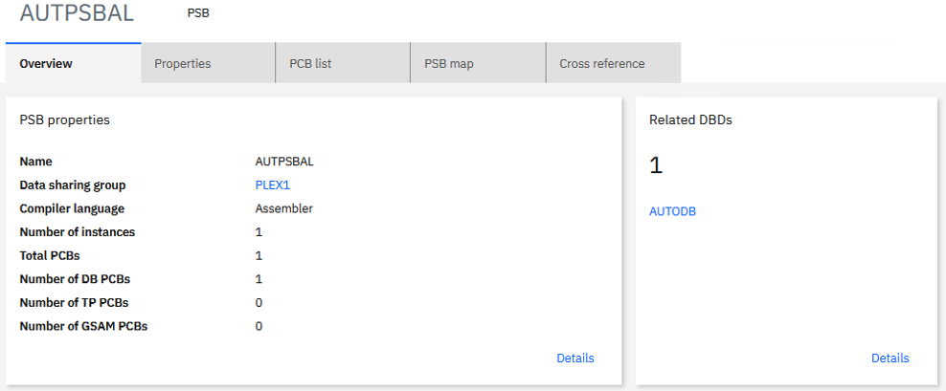

You can perform similar operations for other resource types.

This completes Scenario 2.

Scenario 3: Search IMS objects
In this scenario, you perform a cross-resource search (DBDs, PSBs, online resources) by specifying filtering conditions.

- On the dashboard, click the right-most tile: “Explore objects”.

If this dashboard is not visible, click “IBM Unified Experience for z/OS” in the navigation bar to return to the dashboard.
- Confirm that a screen appears where you can enter search criteria.
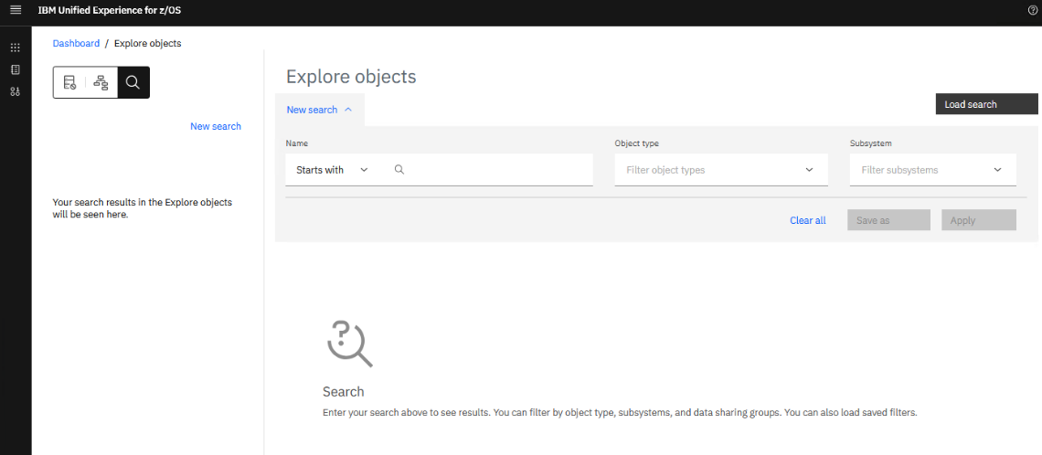
- The available search criteria include:
  - Name: resource name
    - Contains: resource name contains the specified string
    - Starts with: prefix match
    - Ends with: suffix match
    - Matches: exact match
  - Object type: resource type (Note: “Group” refers to DBRC group)
  - Subsystem: IMS data sharing group
Enter criteria and click “Apply”.
The following example shows retrieving resources whose names start with “AUTO”.
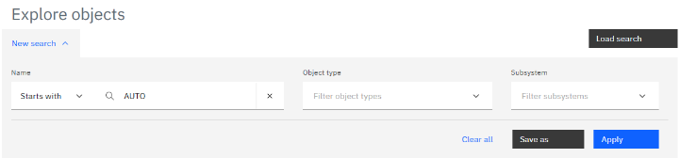
- Resources that match the search condition are listed at the bottom of the screen.
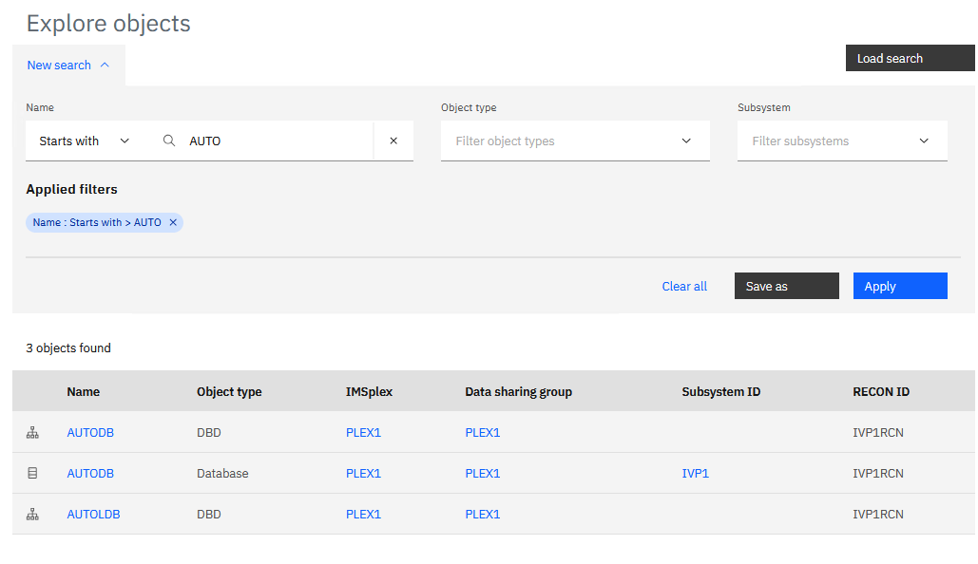

- Click a resource name in the “Name” column.
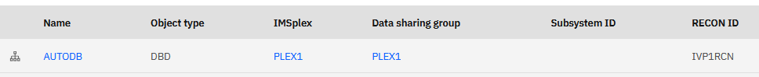
Then, the overview page of dashboard for the selected object is displayed.
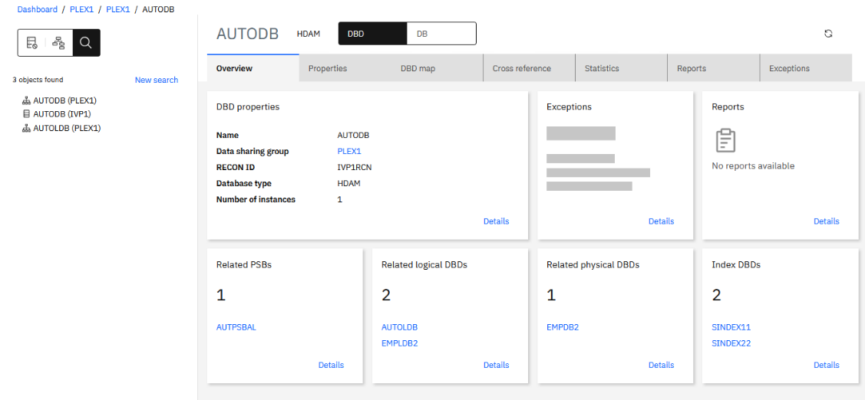
Tip: If you want to inspect other objects from the same search results, select the resource name from the left menu.


This completes Scenario 3.

Scenario 4: Use the IMS Catalog to query DBD/PSB information
In this scenario, you query IMS Catalog to search DBDs or PSBs that have specific set of attributes.

- On the dashboard, click the center tile: “IMS components”.

If this dashboard is not visible, click “IBM Unified Experience for z/OS” in the navigation bar to return to the dashboard.
- On the next screen, the left side shows a list of IMSplexes for registered IMS data sharing groups.
Select the IMSplex “PLEX1”, then select the “Data sharing group” tile or select the first child “PLEX1”, which is the registered name of an IMS data sharing group that belongs to the selected IMSplex.
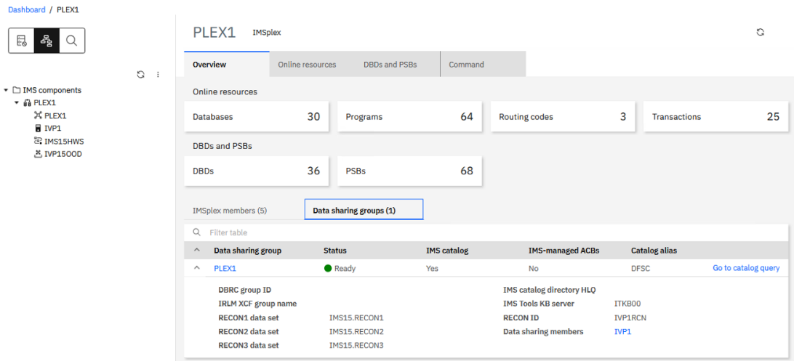
- Then, click the “Catalog query” tab on the top right of the data sharing group page.
The catalog query dashboard on the next page will be displayed.
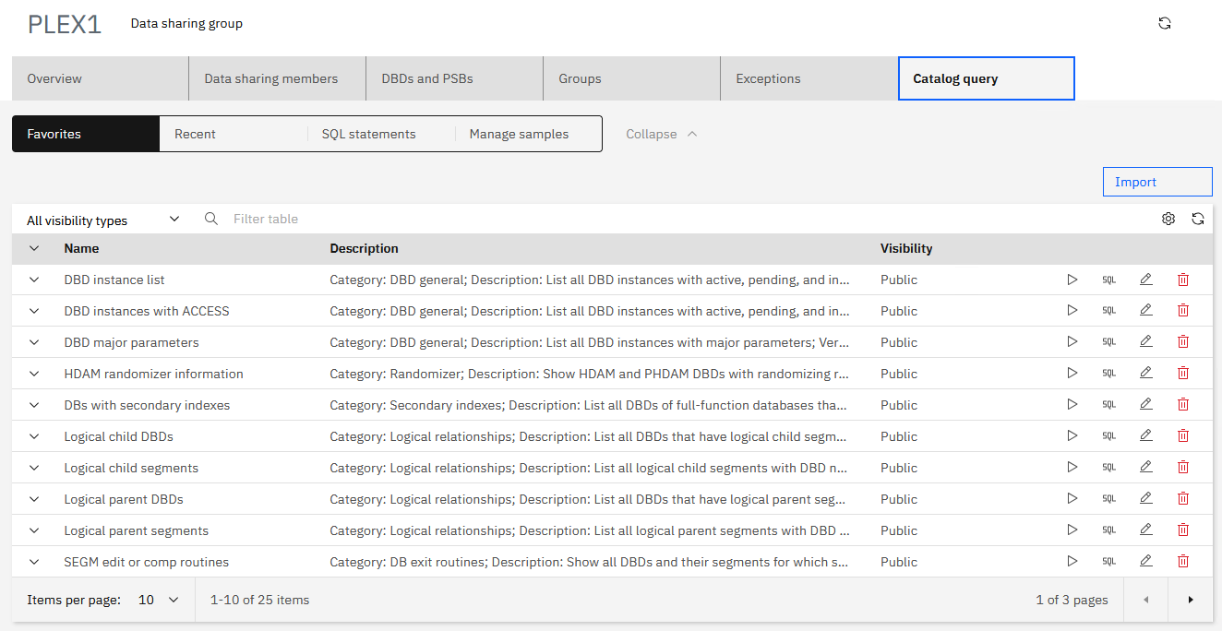
Initially, only SQL statements pre-created by a UMS administrator are listed. Those administrator-provided queries are called “public favorite statements” and can be used by every user.
- The list in the “Favorites” tab can be used for keeping frequently used favorite queries.
You can create your own SQL statements from scratch and save them to the list as your own private favorite statements. You can also edit a public favorite SQL statement entry, modify it, and save it as your own private favorite statement.
Click the right arrow on the bottom right of the table to go to Page 2. Then, select the entry of the name “DEDB randomizer information”.
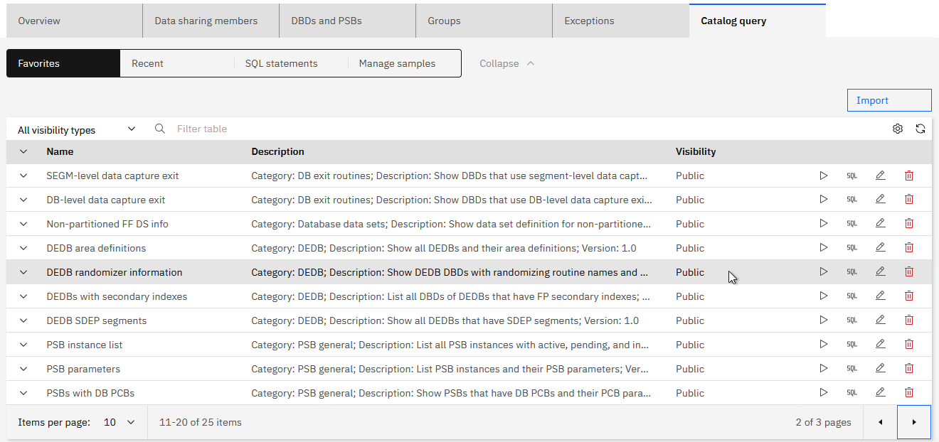

- Click the “SQL” icon at the right end of the row to display the SQL used for the query.

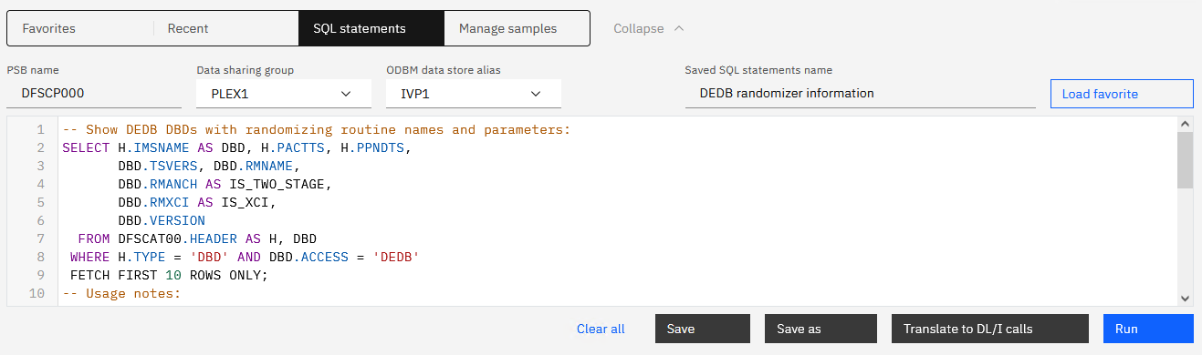
- Click “Run” button at the bottom right to run the query. A table displays DEDB DBDs and their randomizer information. In this lab system, only 4 DEDB DBDs exist. In general, only the first 10 DBDs are returned since “FETCH FIRST 10 ROWS ONLY” is specified. Change the number or remove the FETCH clause to display more, less, or all DBDs.
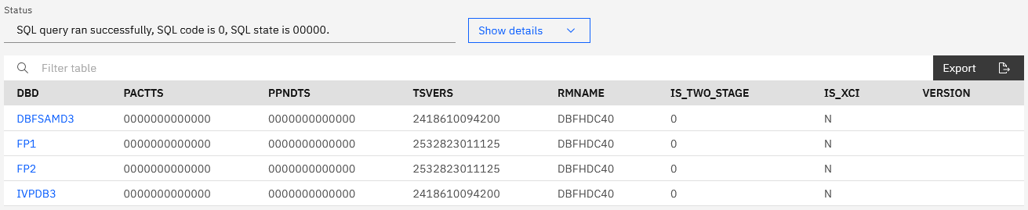
- To see details of a DBD in the result, click its name in the result table. This opens the detailed resource page. For details on the resource page, see “Scenario 2: Review IMS system components and .”

The product provides built-in catalog-query SQL statement examples. Some of all examples can be imported by UMS administrators. Administrators are expected to select and optionally customize imported examples to prepare site-specific public favorite SQL statement samples that can be referred to and used by all IMS Administration Foundation users.

This completes Scenario 4.

Scenario 5: Run IMS SQL for application databases


- Click the hamburger menu icon on the top left corner.
From the opened menu list, select “Run” then select “SQL”.
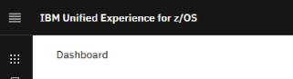
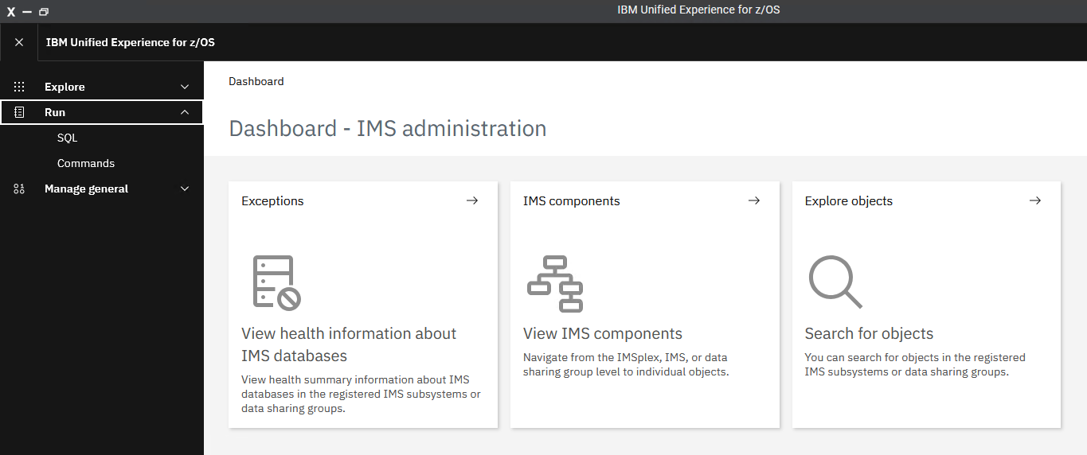
The SQL execution page (SQL Processor page) opens.
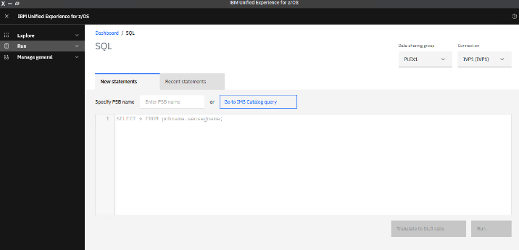
- The target IMS data sharing group and ODBM datastore (alias) are displayed on the top right of the page. If multiple data sharing groups are registered or multiple ODBM datastore aliases for a selected data sharing group exist, you can select an ODBM datastore to connect by using these list selectors.
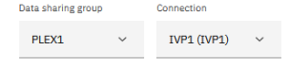
- In the “New statements” tab, enter the PSB name to connect to.
Enter “DFSIVP37”.
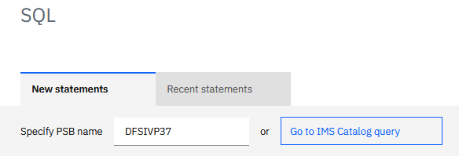
- Enter the SQL in the text field in the center of the screen.
Enter the following, then click the Run button on the bottom right:
SELECT * FROM PHONEAP.PHONEBOOK
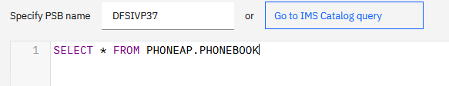
If there is any SQL syntax error, the error location is underlined in red.
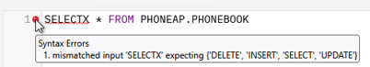

- Confirm there is no syntax error, then click the “Run” button to execute the SQL.
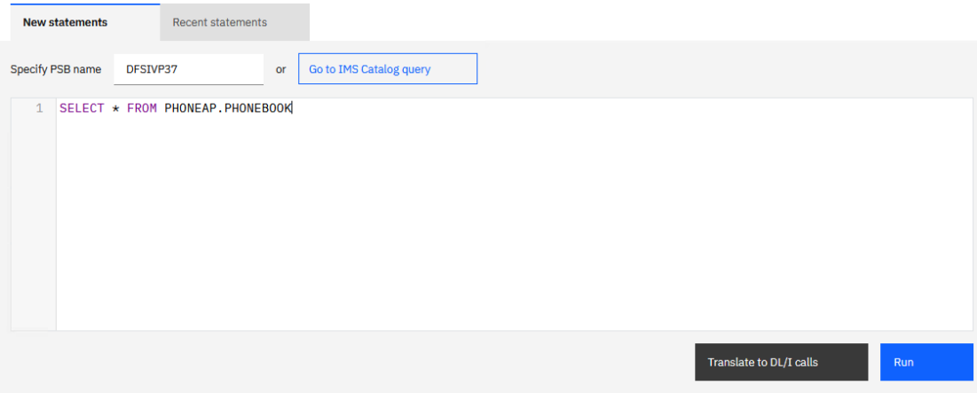
Tip: By clicking the “Translate to DL/I calls” button, you can see how the SQL statement you entered will be translated to DL/I calls.
- If execution succeeds, the results are shown in a table at the bottom.
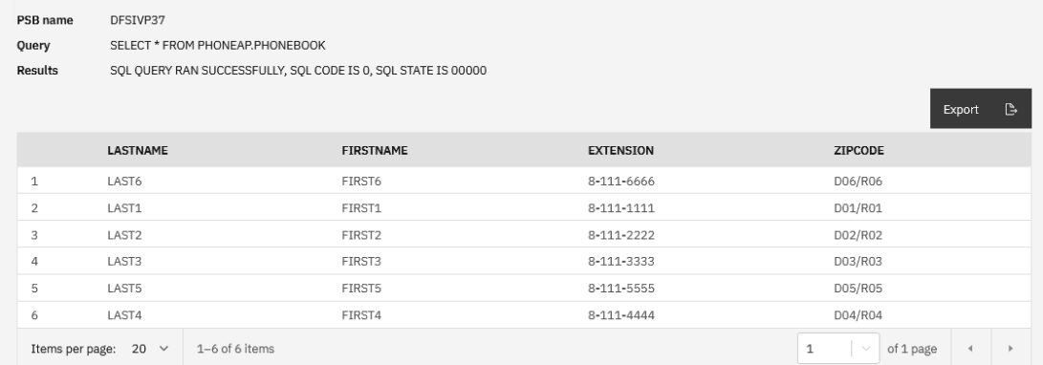You can export the result set by clicking the “Export” button on the top right of the result table.

This completes Scenario 5.

Scenario 6: Run IMS type-1 and type-2 commands

- Click the menu icon in the upper-left (hamburger/menu icon).
From the opened menu list, select “Run” then select “Commands”.

- In the IMS command field, enter an IMS command.
First, enter the type-2 command: QUERY IMSPLEX NAME(*) SHOW(ALL)
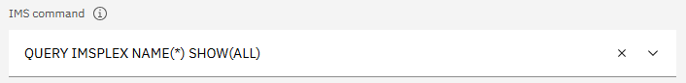
This command will return information about all IMSplex members.

- Select the IMSplex “PLEX1” and click the “Run” button to execute the command.
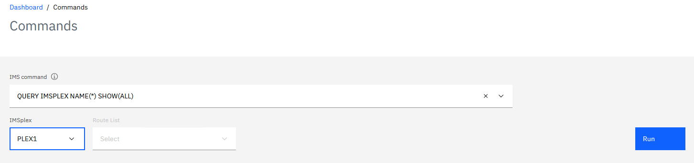
- If the command succeeds, the IMSplex member list is displayed in table format.
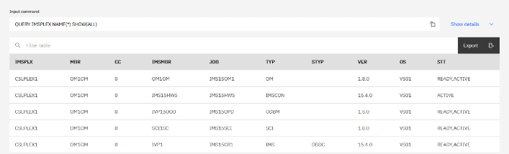
- You can also execute type-1 commands on the same screen.
For example, enter the type-1 command: /DISPLAY ACT REGION
One of the enabled Route List entries is selected for the command automatically.
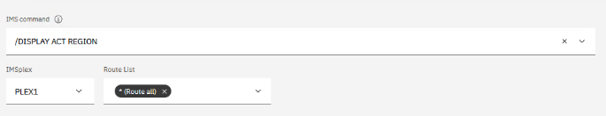
- If the command succeeds, the result is displayed at the bottom of the page.
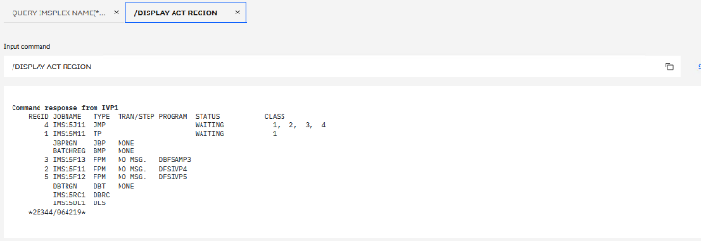
- A new tab is created for each command result. To review or reuse previously executed commands and results, select the corresponding tab.
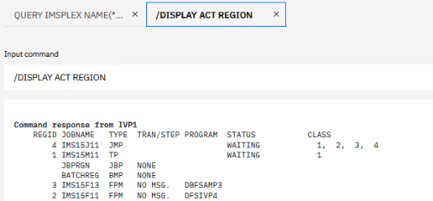
- You can rerun a command from the command history.
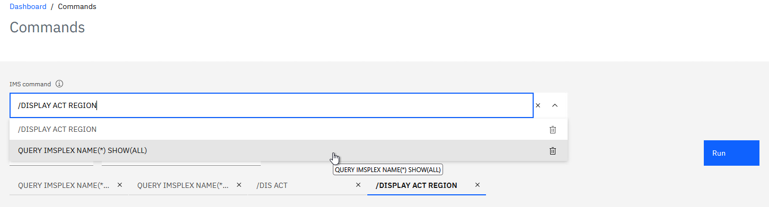

This completes Scenario 6.

